GSIL 2020 Student Workbook

Empathize: Conduct Research to Develop an Understanding of Your Users

Presenter and student materials draw on author materials, IDEO HCD Toolkit the Field Guide to Human-Centered Design, and Design Thinking for Educators.

- Empathize:

Conduct Research to
Develop an Understanding of Your Users

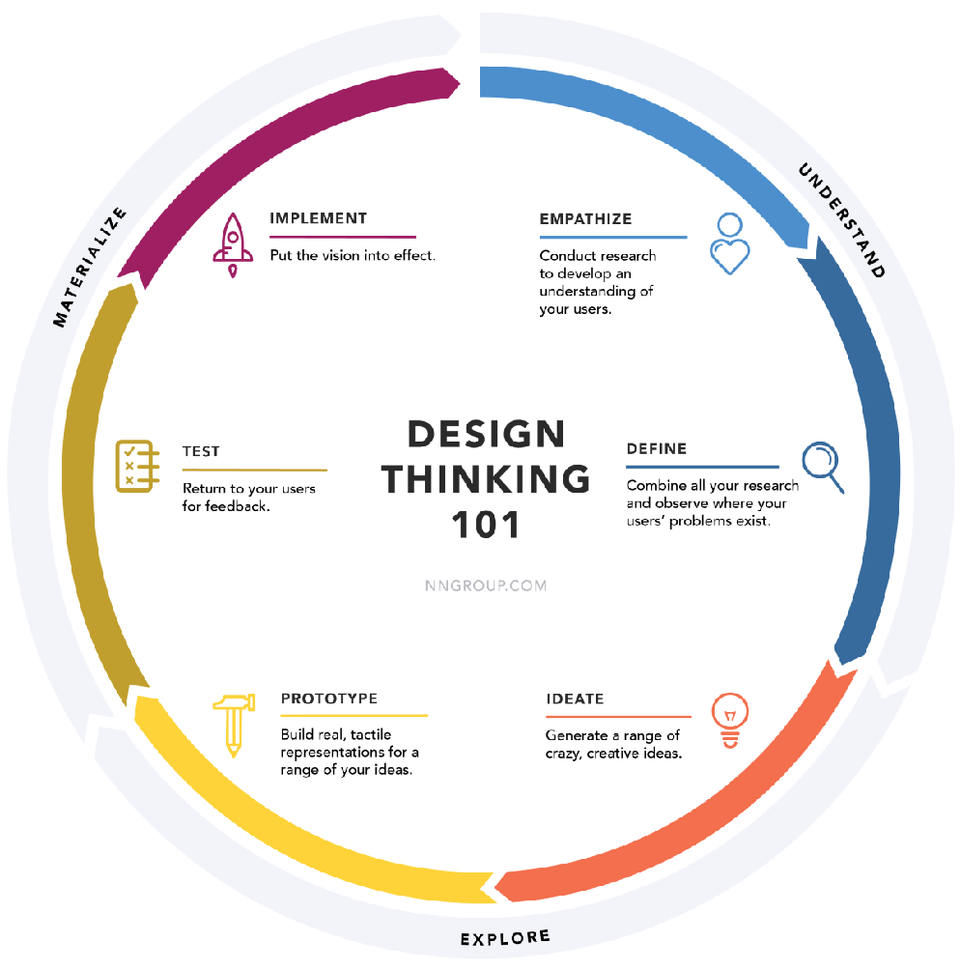

Design Challenge:

Promote Equity, Diversity, and Inclusion in Global Development for Greater Impact

TEAM HYPOTHESIS:

We want ______________________________________________________________________

to ___________________________________________________________________________,

so that... ______________________________________________________________________.

Empathize: Context

What are some of the things your team Identified about the current design challenge?

What do you already know about this challenge?

What would you Iike to learn more about? Capture your assumptions and questions

What are some examples of ways that others are tackling this challenge that appear to be working?

From looking across this information what are some features of the context you are working in that stand-out for you? These might be common problems, common features of successful solutions, things that have led to failure in the past

Worksheet: Define You’re Audience (this can change and evolve)

Who will you be designing for? Consider the core audience and extended audience. Draw a picture of both.

Empathize: Build an Interview Plan & Guide

Worksheet: Prepare Research Interview List

Select Research Participants
Who specifically do you want to talk to and learn from? Create detailed descriptions for at least three different users. be sure to cover a variety of gender, experience, ethnicity, etc.
Note: Interview at least 10 people who would be users of our solution. It can be easier to reach and Interview people who are "experts" who sometimes look, and sound more like us.

Identify Other Sources of Inspiration
Who are other people Involved In your topic? Which experts do you want to meet with to learn more about your topic? List the candidates that you think will provide the most Inspiration and circle those that you want to engage with first.

Identify Places of Inspiration
Where can you go to have an inspiring experience related to your challenge? If necessary, consider what are analogous settings who you might witness similar or relevant behaviors and activities in a different context. List as many locations as you can and then circle a smaller number of those that you are most excited to observe first.

Interview Guidance

Tips for Success:
- You are looking for common themes and behaviors across users.
- Open Questions: Let them do the talking and lead where the conversation goes.
- Past Behavior and Stories: Prompt them to tell you a story of what happened in the past and never ask about future behavior.
- Script: Have a script with questions to help guide your conversation, but be flexible to follow the user’s experiences and insights.
- Dig Deep!
  - Ask “Why?”
  - Tell me a story when…
  - Show Me
  - Draw it

Sample Questions

Understand the Problem:
- What challenges do you face when…?
- What do you spend most of your time doing?
- Tip: Listen for habits

Existing Alternatives (Understanding the solution they currently use, or have cobbled together):
- How do you currently deal with …? What is your preferred [solution]… ?
- What is the most frustrating part of X solution?
- Are there other options?
- What would make you change to a different alternative?
  - Listening for anxieties that may make switching difficult

Observation
- What can you learn during the site visit – what do you see?

Prepare
Assign responsibilities before each interview.
Who is in charge of confirming date, time and location?
Who will ensure you have the necessary equipment?
Who will lead the interviewing?
Who will document?

Worksheet: Interview Script
Start broad and go deep

Welcome
Explain backstory
Empathy
Let them know that this interview is about them, and their stories and problems
Questions for understanding the problem
Start with generic inquiries, then make in-depth inquiries go deep.
Ask lots of questions and follow leads – use the “5 Whys.”
Aim to understand the user experience, including everyday life. Utilize Draw It; Show Me; and Tell a Story.
Existing Alternatives
How is the user solving it now?
Use the “5 Whys;” Draw It; Show Me; and Tell a Story.
Who Else?
Ask for referrals of others who may have similar problems that you can interview
Ask for Permission to Circle Back
If strategic, ask for permission to circle back to share ideas for solutions.

Tip: Check-in for availability in the Saturday afternoon to Sunday morning timeframe - when you'll be testing your solution. Courtesy tip: if they expect to hear from you and down the line you decide it's not strategic to be in touch with this person again, let them know.

Worksheet: Capture Interview & Insights (complete for each interview)

Page 1

Name of interviewee/location/date & time:
Interviewer:
Others present and their roles:

Observations and Quotes

Worksheet: Capture Interview & Insights (complete for each interview)
Page 2

Insights: After the interview reflect on these questions and capture your insights:

- What is this person trying to achieve? What are their goals and wishes. Use verbs to describe this. Consider both physical and emotional needs.
- What did this participant care about most?
- What motivates him/her
- What frustrated him/her?
- What questions would you like to explore in your next conversation?
- What was interesting about the way him/her interacted with their environments?
- What was the most memorable and surprising story?
- What workarounds and adaptations have people made to a make a system to serve their needs better such as books stacked under a laptop to make the screen a better height for viewing?
- What new learnings did you identify about your user’s feelings and motivations.
- What’s something you see about your user’s experience that maybe they don’t see?
- What discoveries did you make that you might be able to leverage?

Present your findings in a short 2-minute presentation on Sat. morning, Jan 25.

Template for “4 Slide Deck” to guide your presentation can be found here.
Send completed deck to Briana Butler (Bb11055) and Ina Ajazi (Ia352) by Friday, Jan 24 at 5pm

